Football: Soccer XI v OWFC for Maclure Pot (a)

The annual Soccer XI fixture against the OWFC was another event which succumbed to the pandemic during 2020 so it was with great anticipation that an XI consisting primarily of top year players travelled up to London to re-start the fixture against the former Wykehamists. This year the match was to be the inaugural contest for Maclure Pot, a trophy donated by the Al Gordon Sports Fund and OWFC family in memory of former Don and ardent OWFC supporter Patrick Maclure.

With the exeat weekend starting at Friday lunch time the Soccer XI squad travelled up to London early in order to visit Chelsea FC and a tour of the Stamford Bridge stadium. It was hoped the opportunity to sit in the changing rooms and dug out would help inspire the boys to a victory later that day. We would have to wait to see if the extra drive and motivation would emerge for the match but there were certainly some inspired imitations and accents on show in the press room as several boys gave their best impressions of Thomas Tuchel and Cesar Azpillicueta being interviewed!

The game started briskly with the ball fizzing across the 3G pitch and some early pressure led to a free kick conceded by Soccer XI. Recent OW, Percy Winter (F, 21) struck the dead ball with venom but keeper Ollie Graham produced a strong save. However, Soccer XI didn’t heed the warning and another free kick was conceded on the edge of the box. This time a bullet of a shot went past the wall and Graham giving the OWs a 1-0 lead. Shortly after, a ball over the top from the OWs caught the defence square and a smart finish saw the lead doubled.

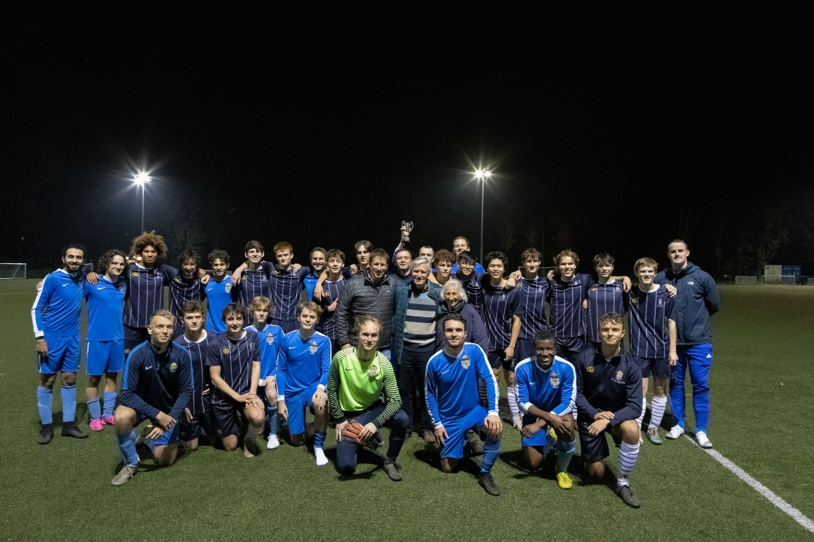

Pleasingly, the Soccer XI boys did not let their hands go down and started to string some neat passages of play together. Central to this was midfield maestro Freddie van Every who began to exert some dominance. From a neat interchange between FVE and Paul Edwards, striker Harry Coombs raced down the right flank before crossing to Lloyd Supompaibul at the far post but unfortunately Lloyd’s shot flashed wide. Subsequent passes from van every put Roderick Passey through and Supompaibul again but both players shot over the bar. Despite going into the break 2-0 down there was plenty of scope for optimism and if we could keep the ball speed and tempo high we might well be able to exploit the fatiguing levels of the OW’s.

With lots of interchanges taking place plenty of boys were getting their chance to contribute and the next clear cut chance went to replacement centre forward Freddie von Finke but he could not quite dink the ball over the advancing OW keeper to cut the deficit. The OWs were still a threat, especially from set pieces and a long throw led to a chance which Ollie Graham saved smartly. Back came Soccer XI and centre back Frankie Shropshire, resembling Virgil van Dyke, went through on a barnstorming run through the middle and unleashed a ferocious shot which the OW keeper pushed over the bar. More pressure was mounted but Soccer XI couldn’t quite create enough clear-cut opportunities to claw back the deficit and the game was professionally seen out by the OWs with aplomb.

Immediately after the match the Maclure Pot was presented to winning captain Alex Dawkins who had done a huge amount of work in organising the match for which we were very grateful. Soccer XI skipper Axel Blakey thanked the Maclure family and the OWFC for their support in putting the game together and presented Alex with a thoroughly deserved man of the match award. (MSB)